**Blood Donation System**

**Introduction**

* The main aim of this project is to save the lives of people by providing blood.
* Our project Online Blood Bank system using Android is developed so that users can view the information of nearby hospitals, blood banks, and volunteer donors.
* This project is developed by three perspectives i.e., Acceptor ,Donor, Admin
* This application we are developing helps to select the nearby Donors,
* This application reduces the time to a greater extent that is searching for the required blood through blood banks and hospitals.
* Thus this application provides the required information in less time and also helps in quicker decision making.

**Member Name:**

1. **Muhammad Awais Siddique (3016)**
2. **Ehtisham Amjad (3126)**

**Database Tables**

1. **Donor**
2. **AppUser**
3. **Blood**

**Homepage**

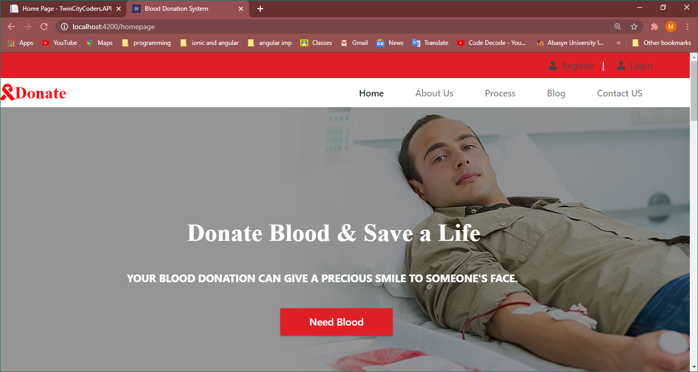

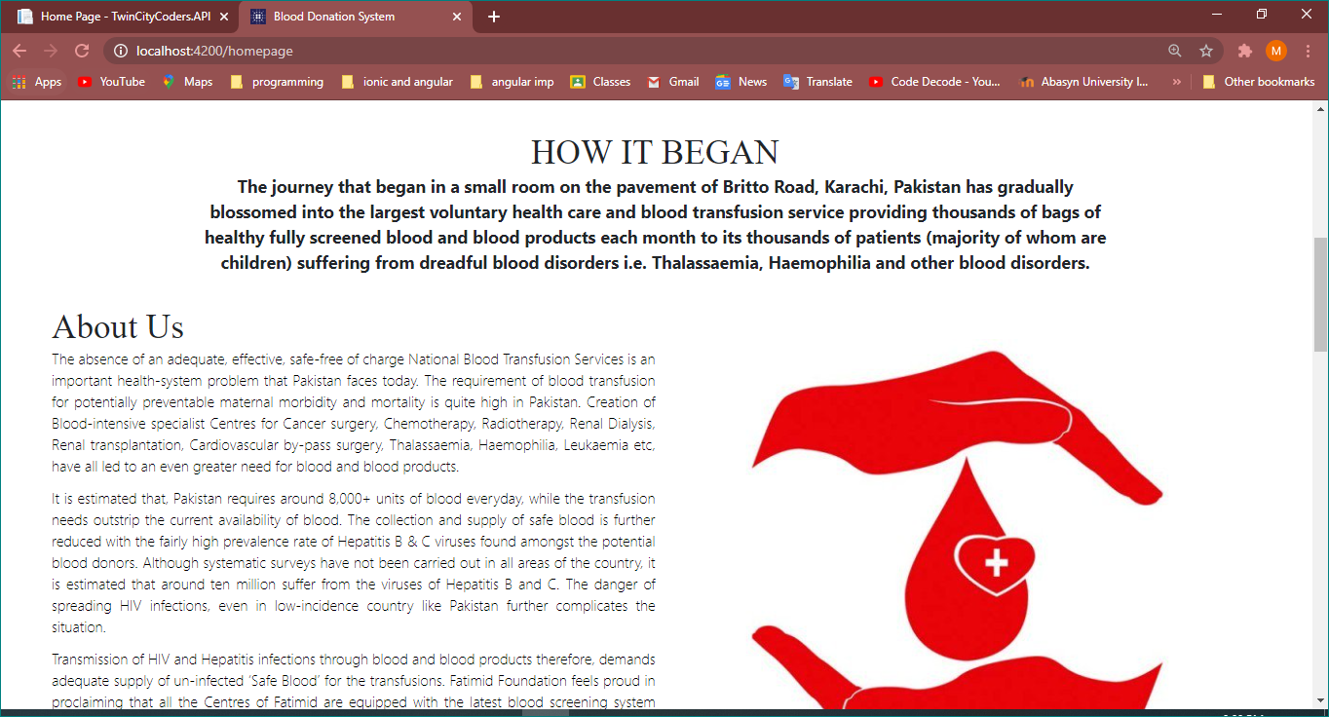

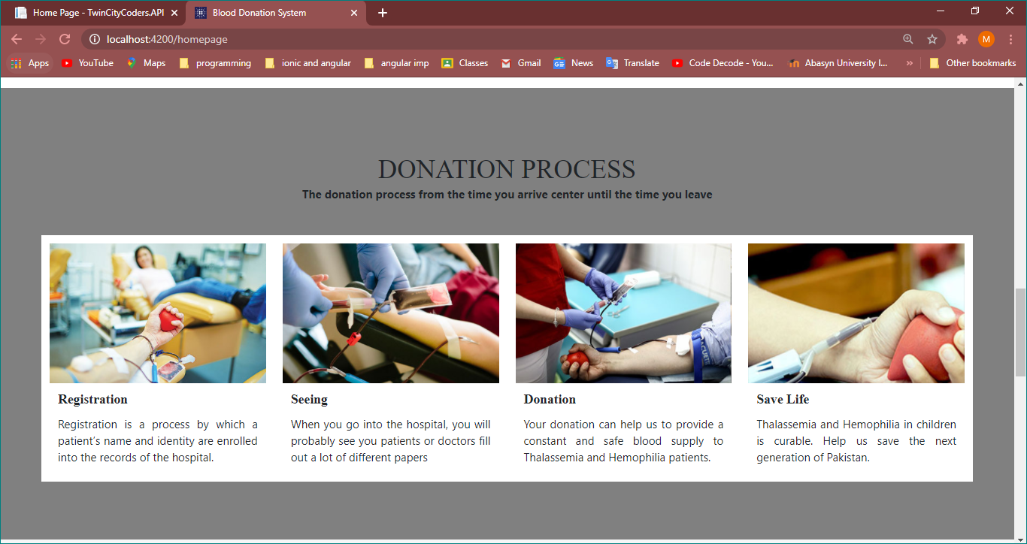

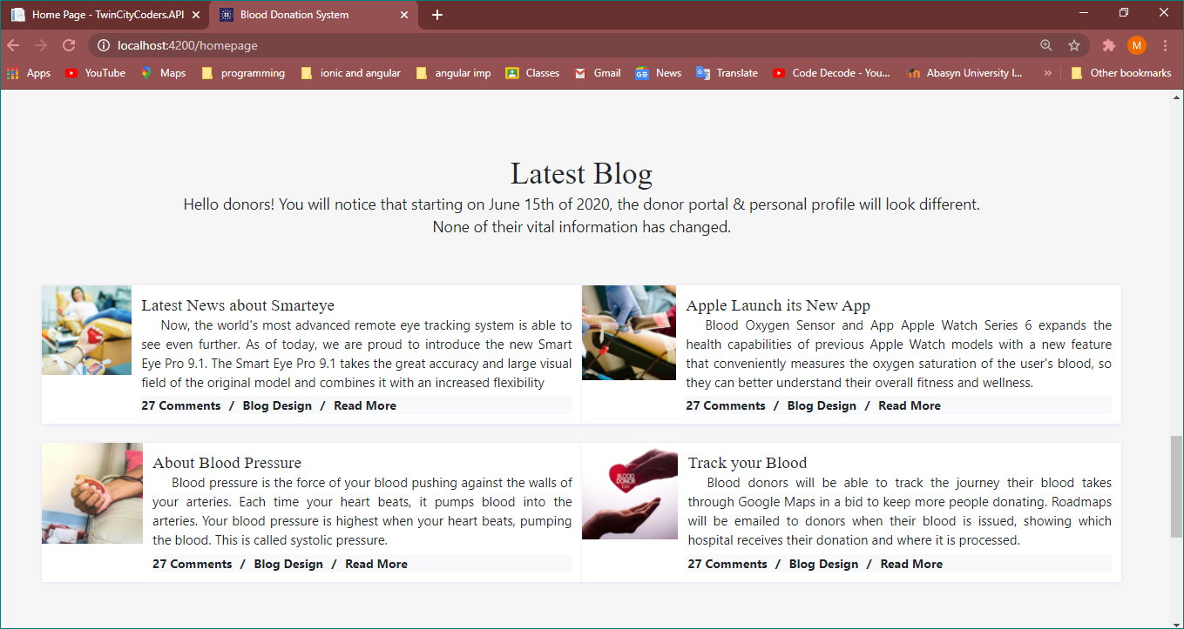

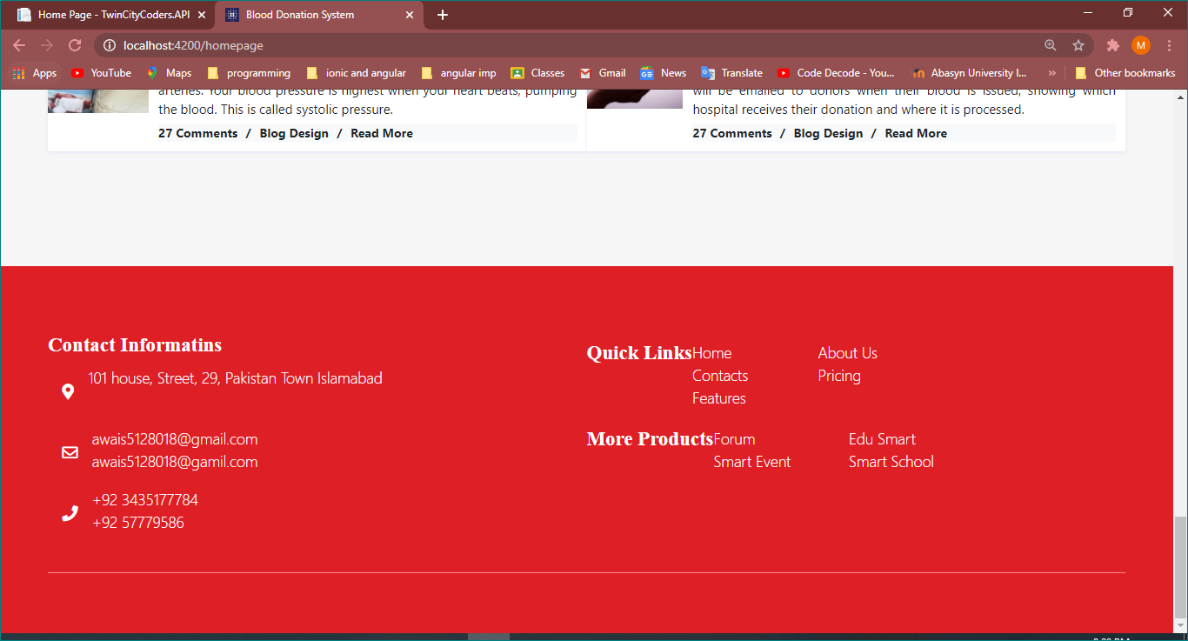

**Acceptor Needs blood**

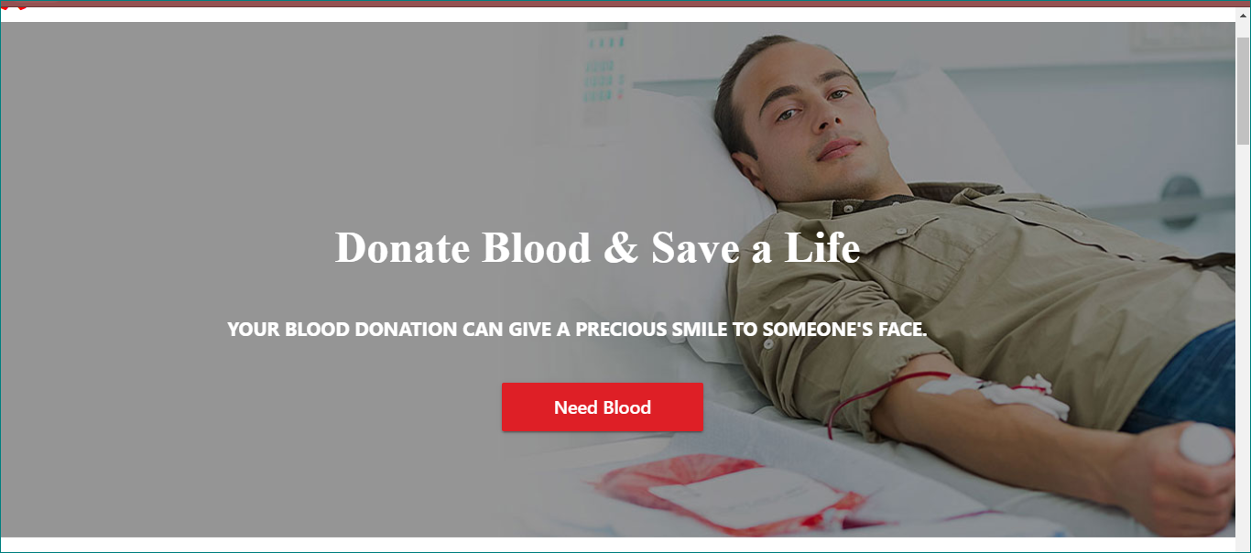

**Click on Need blood (list of donor shown here)**

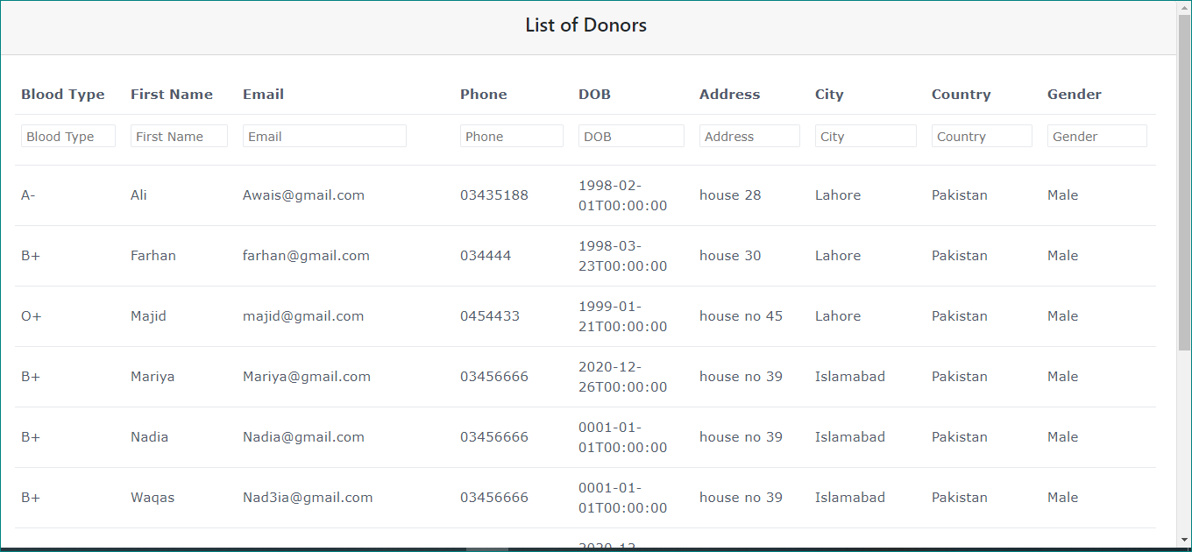

**User enter details(Blood type and Area). That user shown**

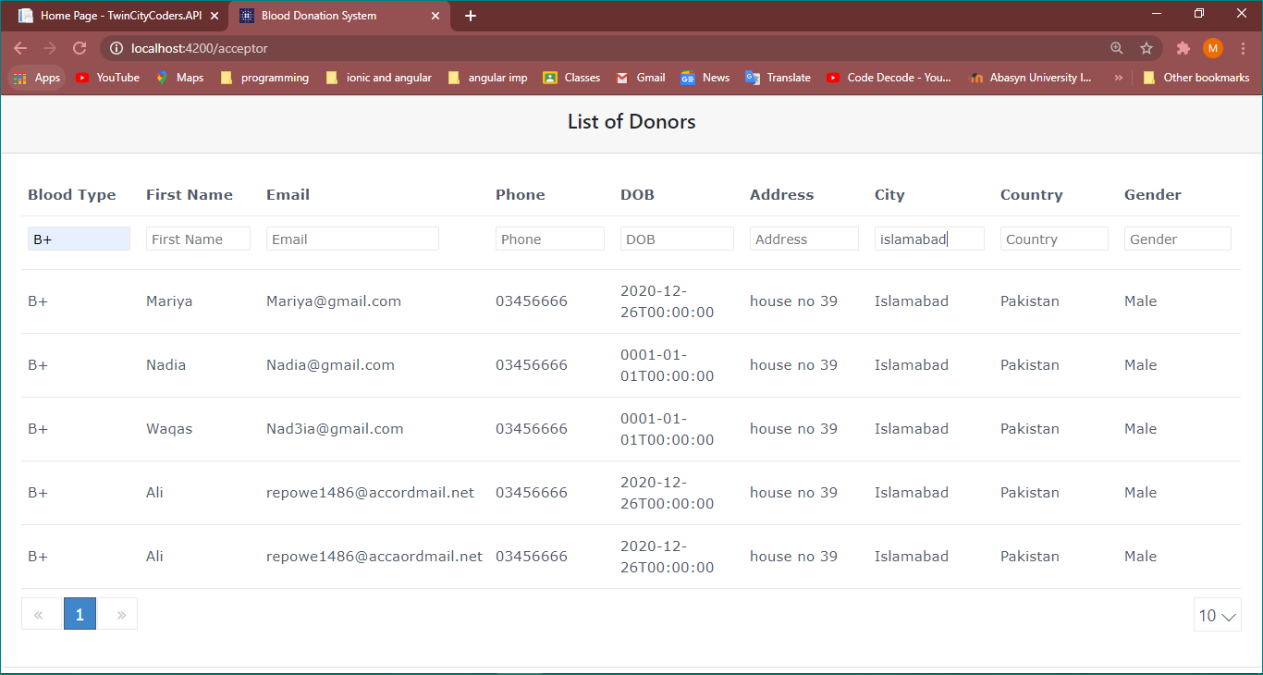

**Login Page**

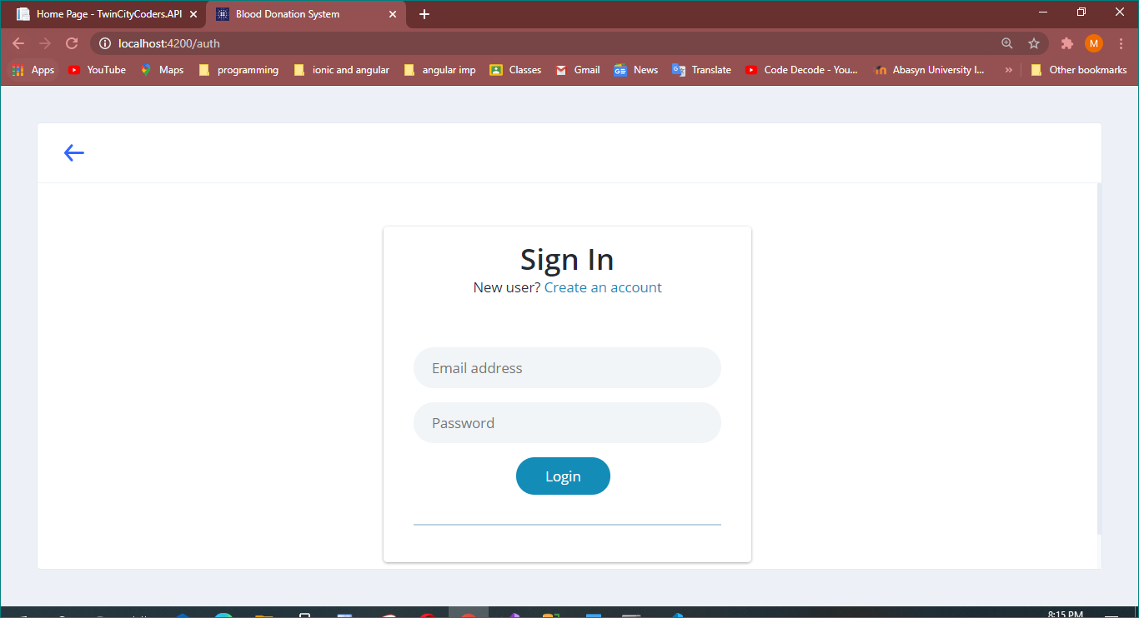

**Validation check**

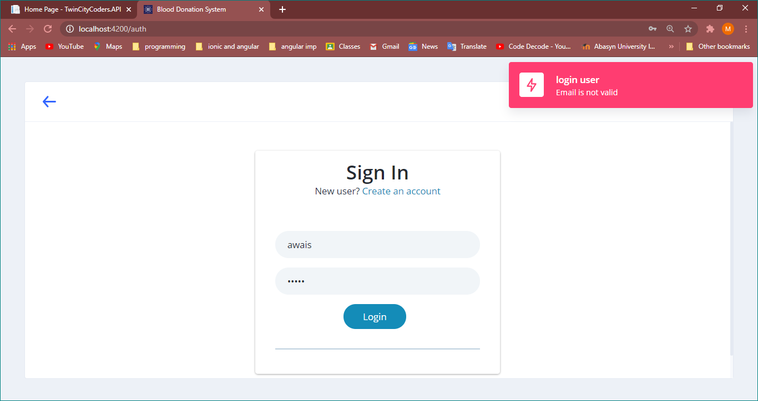

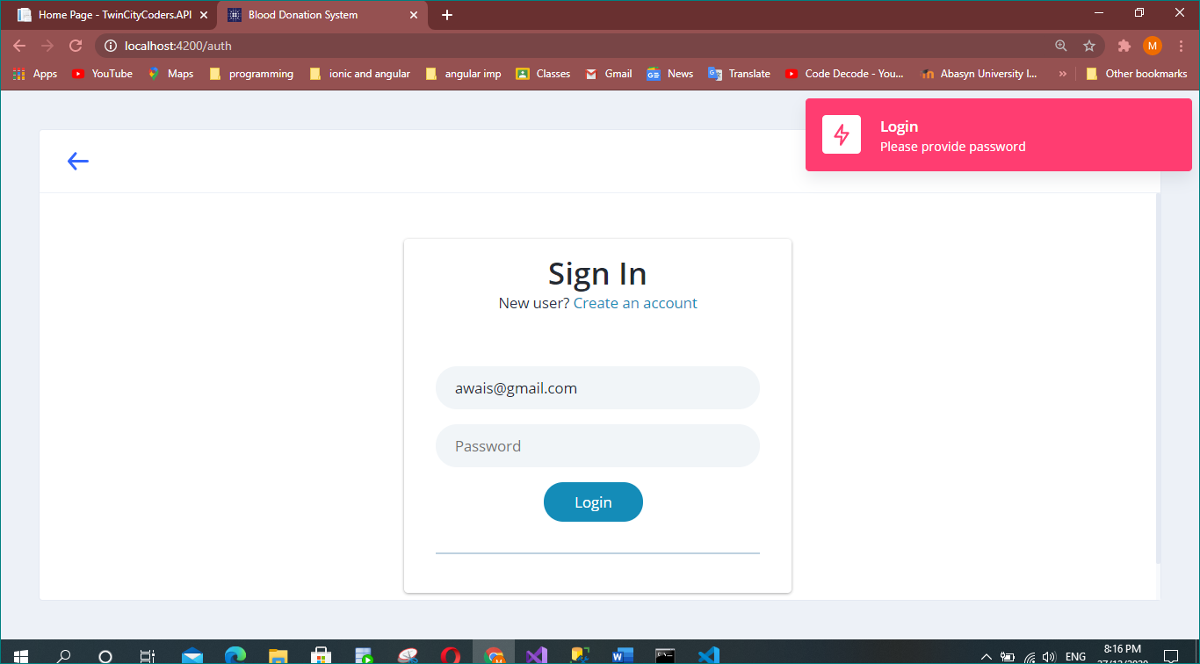

**Same Validation on Unauthorized User**

**Register Page:**

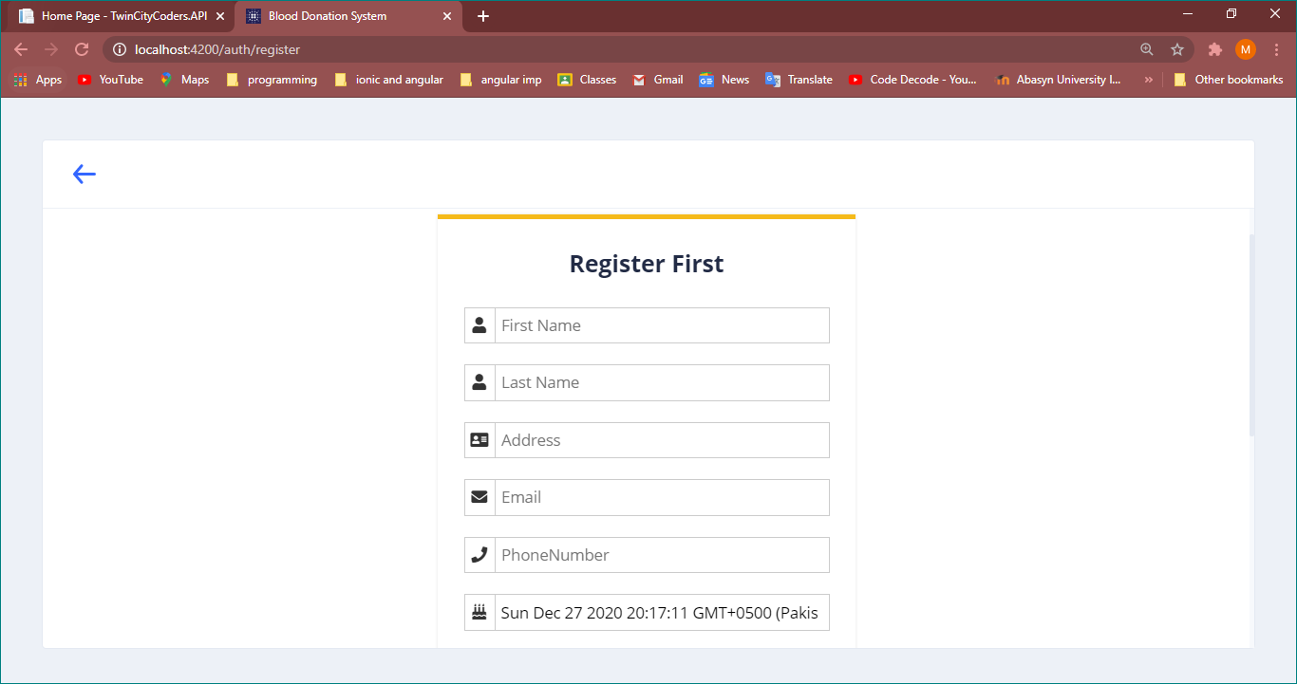

**Validation same as login page**

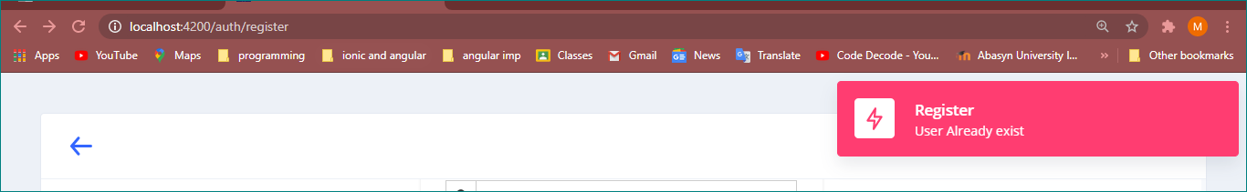

**After User Registered goes on login page and Success message shown**

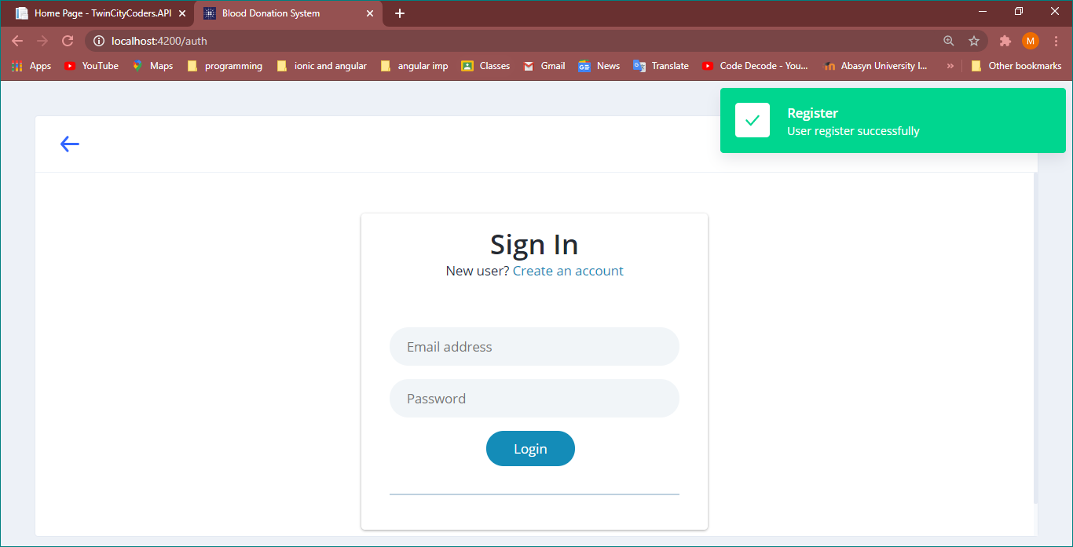

**After Registeration and Login Dashboard page opens**

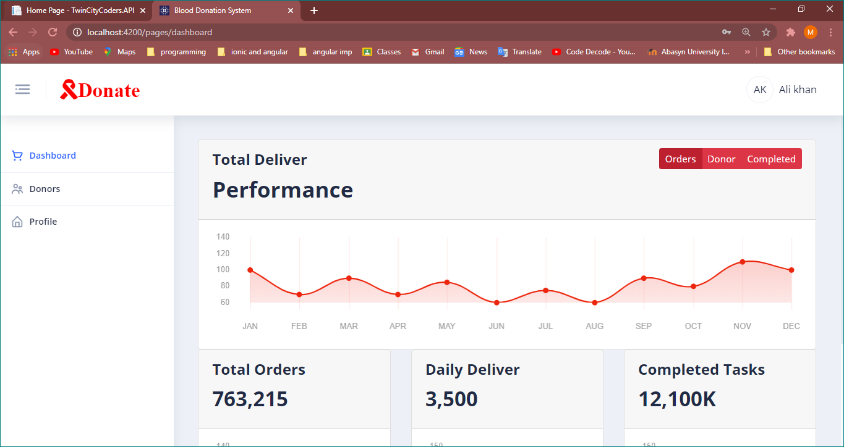

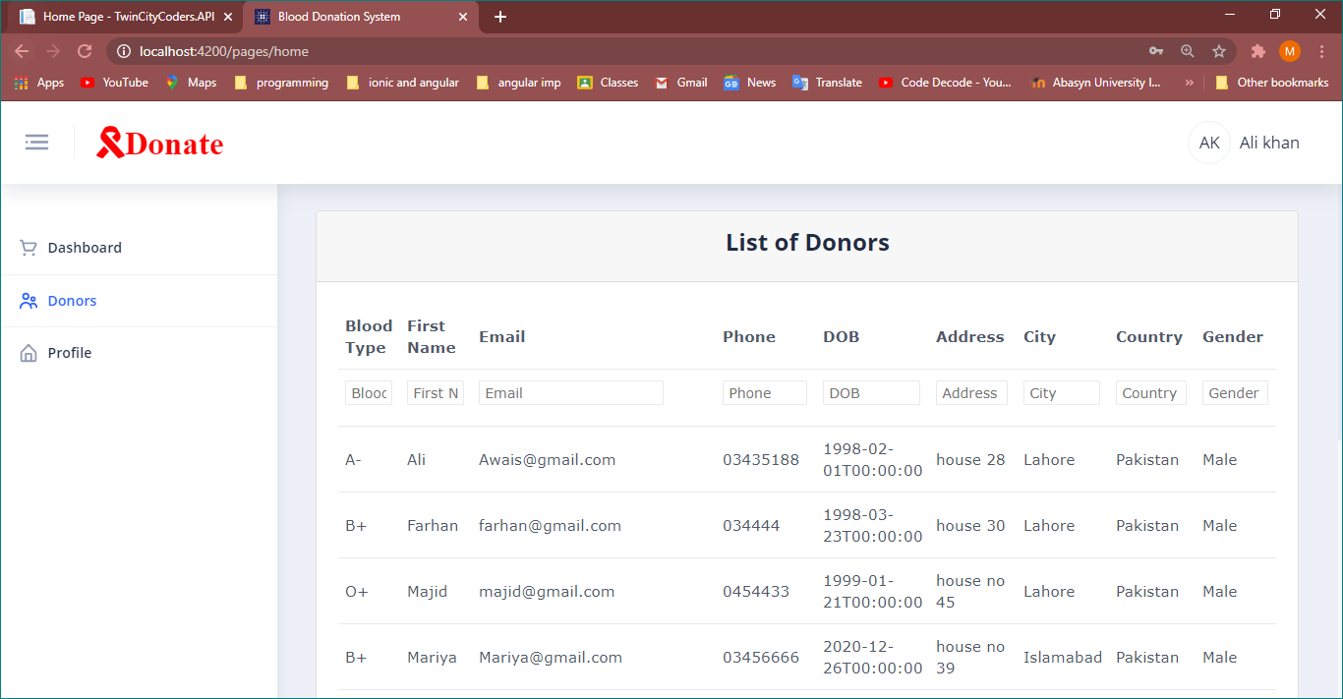

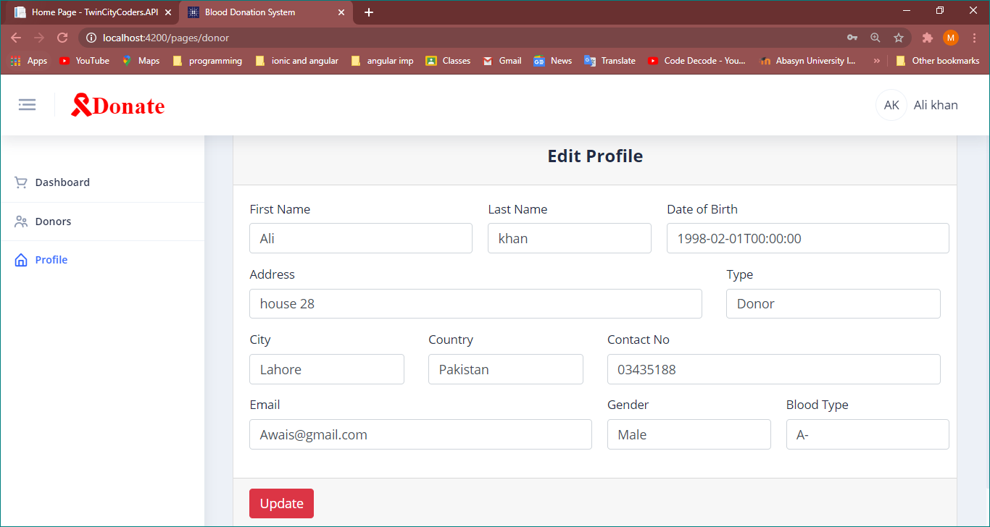

The End